Academic Information vs. Popular Information Sources *

Publications (e.g. books, journals, and websites) have different purposes and are intended for different audiences.
You should always consider whether the information source is relevant to your topic and that it contains information that is up-to-date and is written by someone who knows what they are talking about.
Here are a few things to consider when examining an information source:
- Currency – Is the research up-to-date; not superseded by new research?
- Authority – Are the credentials of the author/ writer clearly visible? Are they experts in the field?
- Objectivity – Is this an opinion piece or information/ fact based?

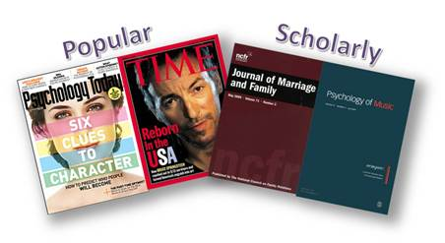

Use the table below to help you distinguish between Academic and Popular publications:

 | Academic Information | Popular Information
Length | - Longer, providing in-depth analysis | - Shorter, broader overviews of topics
Authorship | - Author is usually an expert or specialist in the field.  - Name and Credentials of author(s) usually included. | - Author is often a staff writer or journalist.  - Credentials are often not provided
Audience | - Written in specialized language of the field  - Intended for scholars, researchers, students etc. | - Non-technical language directed at general audience.
Format/Structure | - More structured format.  - May include an abstract, lit review, methodology, conclusion, bibliography/footnotes | - Article may not necessarily follow a structure.
Editors/Publisher | - Reviewed and critically evaluated by experts in the field.  - Sponsored or published by professional organizations, research institutions, universities or scholarly presses | - Evaluated by editors on staff  - Published by commercial or trade publishers.
Credits/  Documentation | - Include a bibliography or works cited, proves that the document was researched thoroughly. | - Usually not provided but reports or references are made within the body of the text
Special Features | - Illustrations and graphs support text | - Advertising and glossy
Examples | - British Journal of Management  - International Journal of Leadership in Education | - Macleans  - Psychology Today

