Where do I find the citation elements for a WEB PAGE?

Gather possible elements from the Web page
- Author - No author, use the title (e.g. Ric Bessin)
- Title of the webpage (e.g. Stinging caterpillars)
- Date of publication - No date use (n.d.) (e.g. 1 October, 2010)
- Name of Website (e.g. UKAG)
- Publisher (e.g. Department of Entomology, University of Kentucky College of Agriculture)
- URL (e.g. http://www.ca.uky.edu/entomology/esvfacts/ef003.asp )
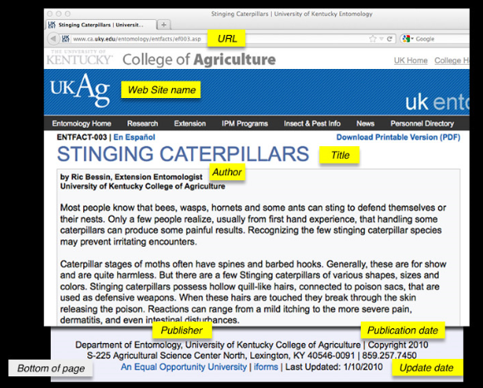
The APA reference for this Web page would therefore be:

Bessin, R. (2010) Stinging caterpillars. Retrieved from http://www.ca.uky.edu/entomology/esvfacts/ef003.asp

Follow the APA Referencing HANDOUT for other examples of Web information you might find.
Also use APA Referencing Websites HANDOUT, or APA Referencing Websites with Missing Information

Exercises
Have a look at the following 2 examples from websites – identify the pieces of information you need to complete an APA reference for a website, and then write out the APA reference (HINT: You can follow the APA format for a website reference from the above example, or look at the examples in the HANDOUTS which are linked on the above page):
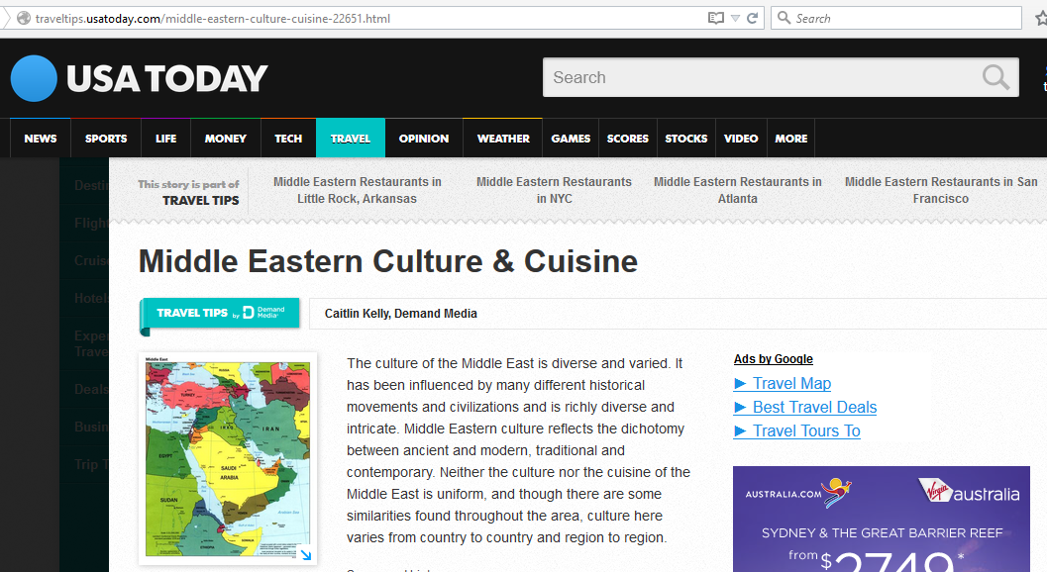
(N.B. There was no date of publication for this webpage)
URL
Web site name
Title of the Webpage
Author
Publisher
Publication Date

APA Reference for this website:

Exercises
Have a look at the following 2 examples from websites – identify the pieces of information you need to complete an APA reference for a website, and then write out the APA reference (HINT: You can follow the APA format for a website reference from the above example, or look at the examples in the HANDOUTS which are linked on the first page):
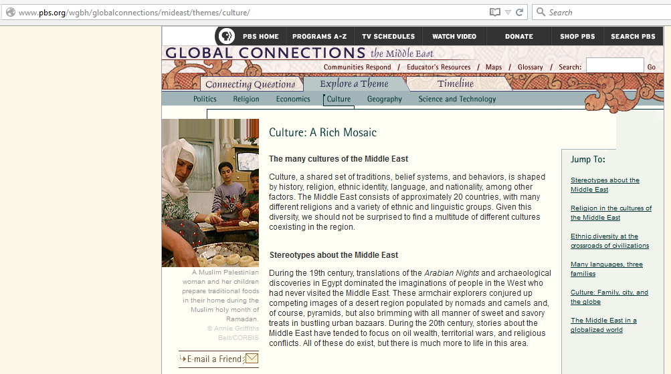
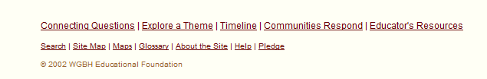
(N.B. There is no author for this webpage)
URL
Web site name
Title of the Webpage
Author
Publisher
Publication Date

APA Reference for this website:

