Where do I find the citation elements for a BOOK?

Use the title page first, and then the back (verso) of the title page – sometimes called the copyright page, to find:

- Author (e.g. Lisa Seachrist Chin)
- Date of publication (e.g. 2006)
- Title (e.g. When a gene makes you smell like a fish … and other tales about the genes in your body)
- City of Publication (e.g. New York)
- Publisher (e.g. Oxford University Press)
- (Edition) * (sometimes included, but not in this example)

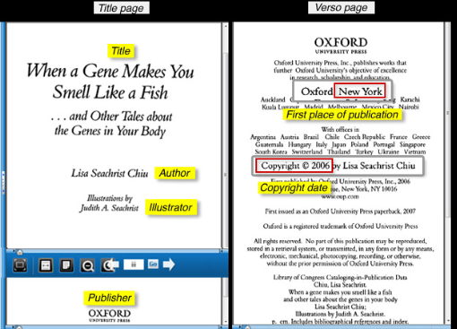
The APA reference for this book would therefore be:
Seachrist Chin, L. (2006) When a gene makes you smell like a fish … and other tales about the genes in your body. New York: Oxford University Press.

Follow the APA Referencing HANDOUT for other examples of book information you might find.

Exercises
Have a look at the following 2 examples from HCT books – identify the pieces of information you need to complete an APA reference for a book, and then write out the APA reference (HINT: You can follow the APA format for a book reference from the above examples):
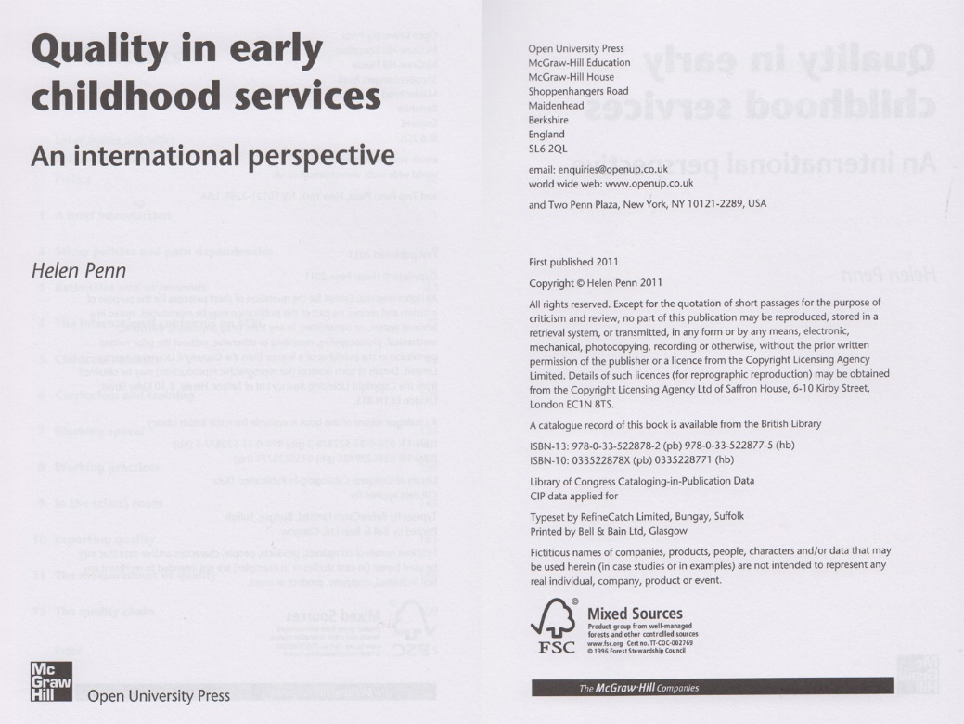

Author
Date of Publication
Title
City of Publication
Publisher

APA Reference for this book:

Exercises
Have a look at the following 2 examples from HCT books – identify the pieces of information you need to complete an APA reference for a book, and then write out the APA reference (HINT: You can follow the APA format for a book reference from the above examples):
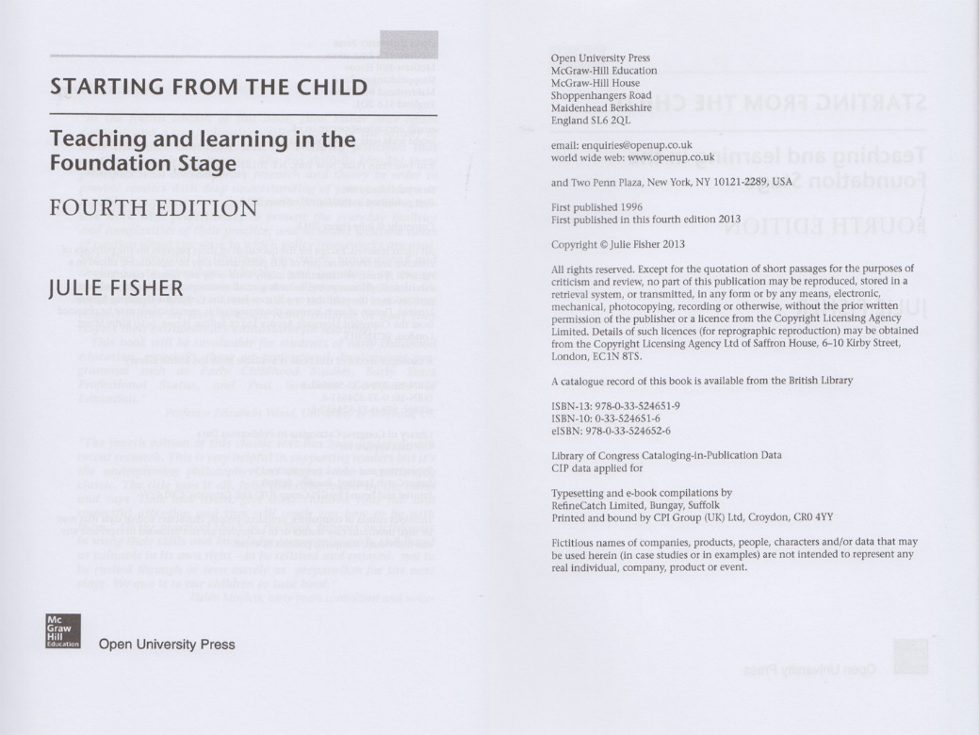

Author
Date of Publication
Title
City of Publication
Publisher

APA Reference for this book:

