WORKSHEET: Successful Searching with Google

Working in pairs or small groups, zip into Google.ae and try the following searches:

Type in… | How many results?
future of robots
“future of robots”
Does adding the “” make a difference? What are the quotation marks doing?
future of robots UAE
future of robots United Arab Emirates
Do you get the same number of results? More or less? Different results?
Now try: future of robots (UAE OR United Arab Emirates) More or less? Why?
future of robots United Arab Emirates
Future of RoBoTs unITED araB eMIRates
Do you get the same number of results? Need to use capitals?
Now let’s look at a particular research question:
Find recent government information about the future of robots in the UAE in PDF

It will be useful now to use the “Advanced Search” option in Google, as well as some of the above ideas:

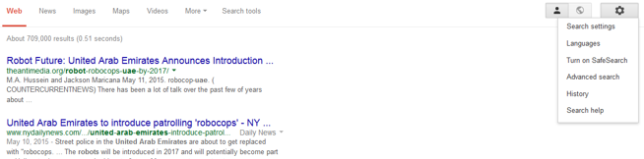

Try the “advanced search” options to find ONLY the results you want!

Limit by the options “any of these words”, “last update”, “site or domain”, and “file type”

Experiment with different options. How many results do you have which match this research question criteria? Do they look like useful academic resources?

………………………………………………………………………………………………………

Share your discoveries

